

ASET Tuner Manual

Latest version: V1.0

2018-02-28

日 期 | 手册版本号 | ASET工具版本号 | 注释 | 作者
2018-02-28 | V1.0 | V3.1.6 | 正式发布版本。 | Kenny

Catalog
1. Catalog 3
2. Preface 5
2.1 About 5
2.2 IC Support List 5
3. ASET Algorithm Intro 6
3.1 Algorithm Brief 6
3.2 Algorithm features 6
3.3 ASET Specification 6
3.3.1 Equalizer PEQ 6
3.3.2 Bass Enhancement 7
3.3.3 High Pitch Enhancement 7
3.3.4 Limiter (Compressor) 7
3.3.5 Dynamic Range Control 7
3.3.6 Sound Effect Enhancement 8
3.3.7 Sound Effect Attenuation 8
3.3.8 Signal Detection 8
4. ASET Tool Description 9
4.1.1 ASET Functions 9
4.1.2 ASET installation and authentication 9
4.1.3 Specification of Firmware Configuration 10
4.1.4 ASET User Guide 10
4.1.5 ASET Main Interface 12
4.1.6 ASET Equalizer Interface 13
4.1.7 ASET bass enhancement interface 15
4.1.8 ASET high pitch enhancement interface 15
4.1.9 ASET Limiter (Compressor) Interface 16
4.1.10 ASET Dynamic Range Control Interface 17
4.1.11 ASET Sound Enhancement Interface 18
4.1.12 ASET Sound Attenuation Interface 20
4.1.13 ASET Signal Detection Page 21
5. Sound Debugging Method 22
5.1 Sound Debugging Process 22
5.1.1 ASET sound flow chart in smart mode 22
5.1.2 ASET Standard Mode Sound Effect Flow 23
5.1.3 Tuning Process of Sample Speaker 23
5.1.4 Tuning Process of Same Cavity Body 24
5.1.5 Tuning Process of Different Cavity Body 24
5.2 Audio Index Test Item 24
5.2.1音箱音频指标说明 25
5.2.2电信号音频指标测试 25
5.2.3声学指标测试 25
5.3 调音过程 26
5.3.1 参考样机音频指标测试 26
5.3.2 待调样机音频测试 28
5.4 音乐试听技巧 30
5.4.1试听环境 30
5.4.2好音质的基本判别 30
5.4.3试听歌曲 31
5.4.4简单频响测试APP 31
5.4.5听感主观描述 31
5.4.6 听音与各频段的调节关系 33
6. Package Firmware Process for Sound Parameters 35
7. 声 明 37

Preface

2.1 About
In this manual, The ASET sound effect system’s rationale and how it works will be introduced, so that the customer could improve their relative ability.

2.2 IC Support List
IC model supports their corresponding ASET sound effect algorithm as follow:

IC型号 | 均衡器 | 低音增强 | 高音增强 | 限幅器/压缩器 | 动态范围控制 | 音效增强 | 音效减弱 | 信号检测
ATS282X | 20 | √ | √ | √ | 两段/三段 | √ | √ | √
ATS282XC | 20 | √ | √ | √ | 两段/三段 | √ | √ | √
ATS281X | 14 | × | × | 限幅器 | × | × | × | ×
7059C | 14 | × | × | × | 两段 | × | × | ×

ASET Algorithm Intro

3.1 Algorithm Brief
ASET is a sound effect adjust system developed by Actions. Customer can adjust the sound effect of their soundbox effeciently in real time with it.
ASET offers friendly UI and support adjusting online, and it is quiet convinent.

3.2 Algorithm features
- Up to 20 EQ setting and each EQ point ‘parameters could be adjust independently.
- Support 2/3 segments DRC, and let "small soundbox" show "great effect"
- Through POST EQ, it perfectly solves the "dry" and "manic" problems after DRC.
- Sound enhancement can intelligently optimize the bass effect of low volume, making the low frequency of small volume better.
- The sound attenuation can intelligently reduce the crack of high volume, so that the high volume can be displayed perfectly.
- Signal detection by detecting the signal during music playing, and adjusting the EQ of each band dynamically. There is a perfect display no matter it is disco music or jazz.
- The virtual low-frequency technology uses the harmonic method to display stronger low frequency through human psychology.
- Support front/rear volume, and 31 levels different sound effects.
- The tuning tool realizes " what you see is what you get " and really lets sound effect be in the hands of the tuner.

3.3 ASET Specification
Eight modules are include in ASET sound effects: equalizer, bass enhancement, high-pitch enhancement, limiter (compressor), dynamic range control, sound effect enhancement, sound effect attenuation, signal detection and other modules. In addition, the parameters of each module could be adjusted individually.
PS: different IC supports different ASET modules. As the list follows.

3.3.1 Equalizer PEQ
The PEQ of ASET could support 20 PEQ points. Each point can be set to SpeakerEQ and PostEQ state. SpeakerEQ state indicates that the PEQ point is placed before MDRC; PostEQ state indicates that the PEQ point is placed after MDRC. Both Each PEQ point gain and Q value can be adjusted individually.

3.3.2 Bass Enhancement
ASET's bass enhancement adopts the advanced algorithm VBASS, so that the small cavity can also reflect the shock power of the bass perfectly. The bass effect of different lumens is shown by adjusting the bass gain and the up to frequency.

3.3.3 High Pitch Enhancement
ASET's high-pitched enhancement adopts advanced intelligent algorithm PEQ, which makes the high-pitched part brighter and crisper with penetrating power. show different high-pitched effects by adjusting the pitch gain and the up to frequency

3.3.4 Limiter (Compressor)
The limiter module of ASET is used to prevent signal overflow and power over standard breaking. The threshold of the limiter can be set to limit the output power, and the starting time and release time can be set to adjust the opening and closing time of the limiter.

3.3.5 Dynamic Range Control
The dynamic range control uses three segments of DRC, which can perfect the dynamic range of the frequency bands of the music signal and improve the loudness of the signal. The threshold, frequency division point, compression ratio, startup and release time of each segment of DRC can be adjusted separately. ASET supports the setting of different DRC parameters in the AUX mode and the non - AUX mode, making the music in all kinds of applications a perfect display.
DRC is divided into two modes: smart DRC and standard DRC. Intelligent DRC algorithm will automatically adjust DRC threshold according to the volume level, make pre-compensation, limit threshold and other intelligent gain compensation, so as to ensure perfect sound experience at small volume, medium volume and large volume. The standard DRC algorithm allows the customer to set up various parameters such as DRC, gain compensation, signal compensation, pre attenuation and other parameters, allowing all kinds of parameters to be set up at various volume levels to meet customer's personalized sound effect customization.

3.3.6 Sound Effect Enhancement
ASET support audio enhancement in small volume / small signal, reflect the bass or other frequency response better, to a certain extent, make a dynamic bass boost and support PEQ; 5 PEQ upgrade, each PEQ point can be individually set work volume or signal range.

3.3.7 Sound Effect Attenuation
ASET audio support the bass or other frequency points slightly reduced when the volume reduced / large signal frequency response. To prevent the speaker in clipped great volume or signal, which make a dynamic PEQ support in some degree; ASET also support reducing the bass and 5 PEQ point decreased, each PEQ point can set up separate in work volume or signal range.

3.3.8 Signal Detection
ASET signal detection module is applied to AUX module. When AUX comes in and music signal is smaller, the bass or a certain frequency can be raised appropriately by adjusting the sound effect enhancement module. so that the hearing sense of the small signal is more powerful. When the AUX in music signal is larger, by adjusting the sound module appropriate and to reduce the bass or a certain period of frequency, making a perfect embodiment of the volume of high quality music and large signal is not easy to break the sound.

ASET Tool Description
The ASET (Audio Sound Effect Tuning Tool) is a PC Tool developed by Actions to adjust ASET Sound. It is a real-time, highly effective tool for tuning the sound box. Through ATD communication methods, the related parameters in the speaker are revised, and user can hear the sound effect of the modified speaker in real time, achieving the goal of efficient debug.

4.1.1 ASET Functions
1) Real-time debugging of various parameters and functions.
2) Support to save the current debugging Settings as templates for next use.
3) Support import and export parameters.
4) Support to export parameters according to the specified template format.
5) Support online debugging mode and offline mode.

4.1.2 ASET installation and authentication
In the ASET software installation package, click on the Setup.exe tool installation, after installation can be in the start menu - > Actions tools - > ASET debugging tools. Then click on the tools icon under menu can open this tool.
After installation, it must be verified before it can be used. The authentication method is as follows:
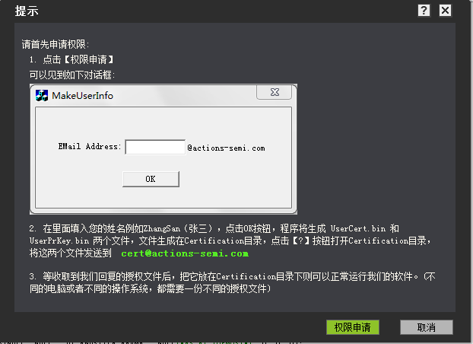
Fig 1 permission application dialog box.

4.1.3 Specification of Firmware Configuration
All ASET configuration items are listed in case\fwpkg\config_txt\*.txt, named after ASET_XXX format, these configuration items corresponding to the parameters of the algorithm modules. User should notice that all the parameters are converted to an integer because of Actions platform does not support floating-point calculations, each conversion relationship in each parameters is explained in the comments.
ASET configuration item is numerous, the parameters and ASET tools are not completely consistent, need to be transformed. ASET tools configuration parameter values in the transfer to the configuration file is a tedious and error-prone. So the ASET tool provides a function that exported configuration items to *. txt file in accordance with the requirements for the firmware file, user just replace the corresponding parts in the firmware file configuration items after the export.

4.1.4 ASET User Guide
The ASET tool relies on ATD drive which is a USB communication protocol developed by Actions independently.
When ASET is installed, ATD driver will be integrated automatically, as long as device connect the normal PC cable, then click on the tool interface connection button, user can see the ATD devices in device manager, as the following figure 2:

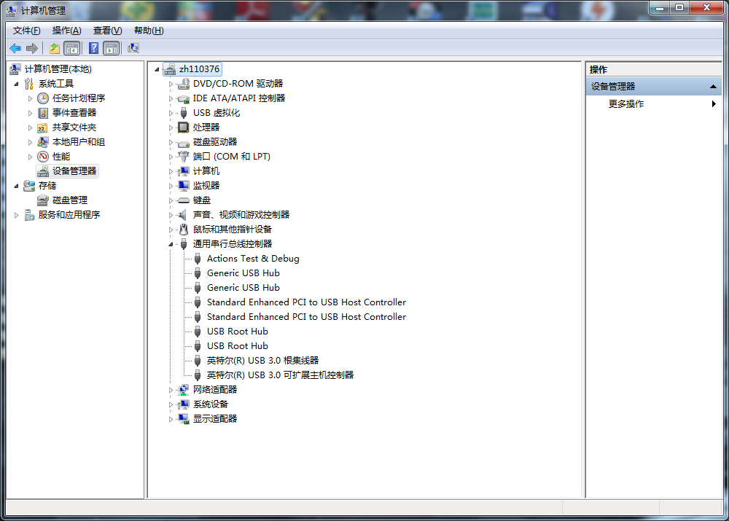
Fig 2 ATD device
After opening the tool, the connection interface appears. If you connect to USB and enter the U disk mode, you can click the "connect" button and enter the online debugging mode.If you don't want to debug, you want to see the last configuration result, or generate the parameter file for ASET, or export the configuration file *.txt, and you can select the offline mode to enter.Figure 3 below:
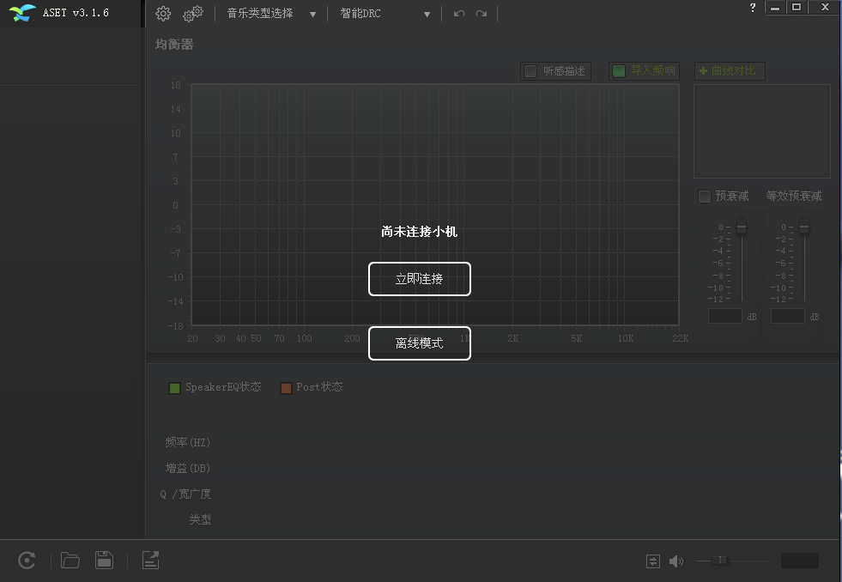
Fig 3 ASET tool
Click "connect immediately" or "offline mode", as shown in figure 4 below：
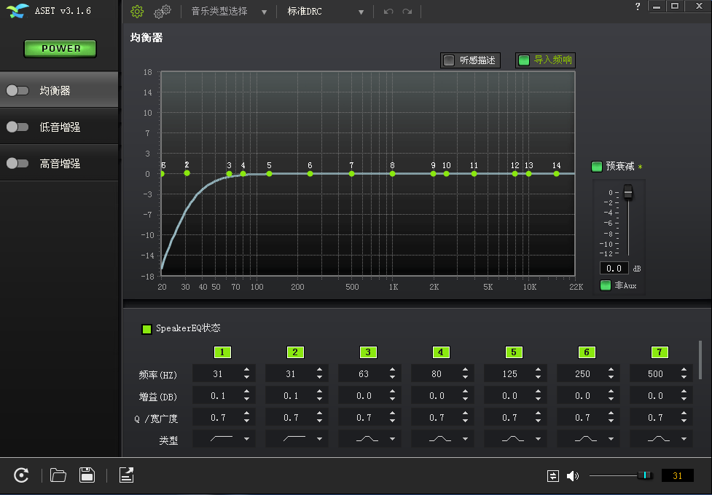
Fig 4 ASET interface

4.1.5 ASET Main Interface
The ASET home page can complete editing and some general Settings.as the following:

- The four buttons in the lower left corner of the main page are common functions. The first one resets all data, and the second one is to load the parameters saved last time. The third is to save the parameters of this debugging; The fourth is to export the debug parameters in the format of the firmware configuration file.

Fig 5 common functions interface

- Tool selection interface. There are three options in the upper left corner of the tool. The first one is "simple mode" and "advanced mode"; The second music type selection has four styles: popular music, scene music, rock style and classical style, etc.The third is the choice of "smart DRC" and "standard DRC" mode.
Fig 6 mode selection interface

- On the left side of the main page, there is a total switch "POWER" button, which is opened by default. If it is closed, all sound effects modules will be closed. Each module of ASET can be turned on and off by the buttons on the left. The simple mode has four modules, and the advanced mode has eight modules.See figures 7 and 8 below.
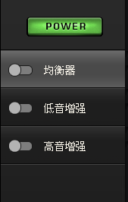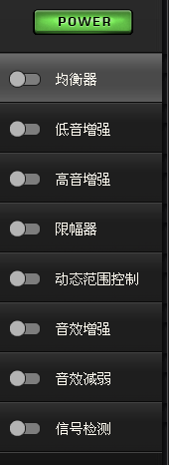
Fig 7 simple mode fig 8 advanced mode
- There is a volume control button in the lower right corner of the main page, which can adjust the volume of the sample machine online.

Fig 9 volume control button

- At all levels, the button is set at the same level, on the left side of the volume button.； Indicates that the parameters of the volume at all levels can be incongruent.； Indicates that the parameters at all levels are automatically changed to the current level.

4.1.6 ASET Equalizer Interface
The equalizer page can adjust the pre attenuation, equivalent pre-attenuation, and various parameters of 20 PEQ points.
- Equalizer page has " import frequency response" and "curve contrast" button, it is to import by the AP test tool to measure the frequency response curve, and displayed in the equalizer workspace, EQ curve can be used to compare the debugging, the accurate reference prototype EQ curve; The import curve supports files in TXT format and Excel format. The curve is used to contrast the set of EQ parameters, and then compare the auditions.
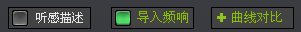
Fig 10 Import the curve
Describe sense button, there you will have a window, display the current mouse real-time in frequency corresponding subjective listening description, it can help us more directional control EQ curve, and it can help debug researchers study the tuning experience.
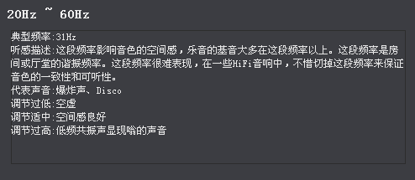
Fig 11 sense description
Pre attenuation setting, pre-attenuation means pre-attenuation before signal processing; In the intelligent DRC mode, the power regulation of small and medium volume; Equivalent damping, sound effects in regulating the signal is the effective value of ascension, estimates that only works when the MDRC opened, according to the PEQ enhance the overall size of estimating a value, if you don't want too much computing the size of the overall ascension, you can use experience - 3 db, and no longer changes.
PS: in standard DRC mode, only pre-attenuation, and can set different values of AUX and non-aux modes respectively.
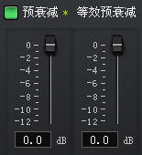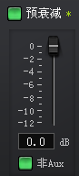
图12 Pre-attenuation, smart and standard mode
4．PEQ point setting can adjust the state, gain, Q value and type of PEQ point.The types of ASET support frequency points include: Peaking，High pass，Low pass，Low shelf，High shelf。
PS：
(1). When the PEQ frequency point is set to "High pass" or "Low pass", the PEQ point gain needs to be set to a non-zero value, High pass to be effective, such as the need to more than 60 hz high pass, point the PEQ frequencies is set to 60 hz, gain is set to 0.1 dB, Q value is set to 0.7, the type is set to High pass.
(2)． Speaker EQ means that the EQ point is placed before DRC, and PostEQ refers to the EQ point after the DRC and limit. When the PEQ point is set to PostEQ, special attention should be paid to the final power of the frequency point to not exceed the standard, and it is better to set the negative gain.
(3)． When PEQ is marked green, the current PEQ point is Speaker EQ; When PEQ is marked orange, the current PEQ point is PostEQ, as fig14。

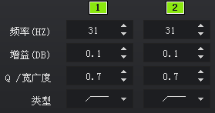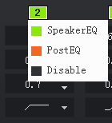
Fig 13 PEQ setting Fig 14 PEQ type setting

5． Curve comparison function, this function can debug several curves on PEQ, and then compare the auditions separately, so that user can choose the best curve.
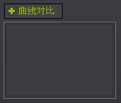
Fig 15 Curve contrast

4.1.7 ASET bass enhancement interface
The bass enhancement page has two parameters that can be adjusted, one is the bass enhancement gain, the other is the bass enhancement cutoff frequency; Different bass requirements different values adjusting.
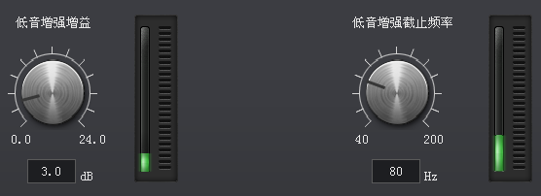
Fig 16 bass enhancement interface

4.1.8 ASET high pitch enhancement interface
There are two parameters that can be adjusted for the high-pitched enhancement page. One is the high-pitched gain, and the other is the bass enhancement cut-off frequency.Different high-pitched demands adjust different values.
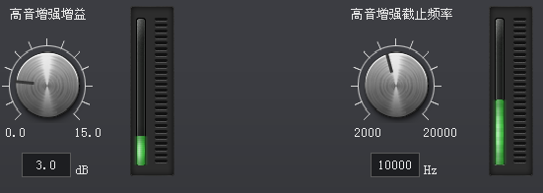
Fig 17 high pitch enhancement interface

4.1.9 ASET Limiter (Compressor) Interface
- In the smart DRC mode, it is called the limiter, and the page has three parameters to adjust: threshold, startup time, and release time.
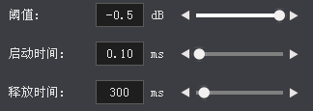
Fig 18 Limiter Interface
- In the standard DRC mode, known as the compressors, there are seven parameters can be adjusted: threshold 1, compression ratio 1, threshold 2, compression ratio 2, RMS detection average time, startup time and release time. This tool also support for adjusting different parameters in AUX mode and non-aux mode.
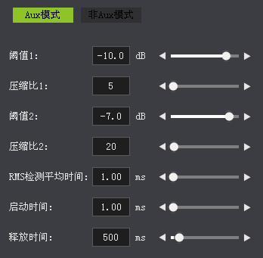
Fig 19 Compressor Interface

4.1.10 ASET Dynamic Range Control Interface
Dynamic range control page parameters can adjust many parameters; There are smart DRC mode and standard DRC mode, and three section DRC or two section DRC can be supported in standard mode. In each mode, the AUX mode and the non-aux mode are subdivided to support different MDRC parameters in the four cases.

- Smart DRC mode
- Power fine tuning: slight adjustments to the final output signal, such as balancing the input size of different signal sources
- Signal attenuation: the output power of fine adjustment, such as the balance of output power of different signal sources, etc.
- Limiter difference: adjust the dynamic range of MDRC to avoid distortion and noise
These three parameters can adjust the automatic compensation size after MDRC compression. Generally, default setting is enough.
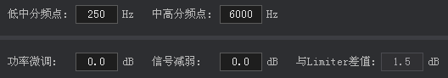
Fig 20 smart DRC parameter setting 1

- ASET algorithm supports three sections of DRC, which can set the frequency range of the three DRC by adjusting the "low middle frequency point" and "high middle frequency point"; Each DRC can adjust the threshold, startup time, and release time.
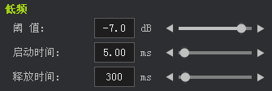
Fig 21 smart DRC parameter setting 2
- Standard DRC mode
- Three DRC and two DRC: support for three DRC and two DRC selection switches.
- Sensitivity: the digital gain adjustment before MDRC can adjust the input sensitivity of different applications.
- Power adjustment: the digital gain adjustment after MDRC can adjust the output power of different applications
- Compensation filter: in order to effectively eliminate the bump of the DRC first divider point; You can set thresholds, Q values, startup time, and release time. The threshold value is referred to as the DRC threshold, for example, the central frequency threshold of DRC is -8db, and the threshold value of the compensation filter is set to -6db, then the raised point amplitude = (-6)-(-8) = 2dB.
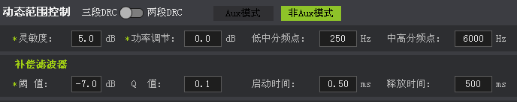
Fig 22 Standard DRC parameter setting 1

- The standard DRC is also divided into three sections of DRC, which can set the frequency range of the three-segment DRC by adjusting the "low middle frequency point" and "high school frequency point". Each DRC can adjust threshold 1, compression ratio 1, threshold 2, compression ratio 2, RMS detection average time, start-up time and release time.
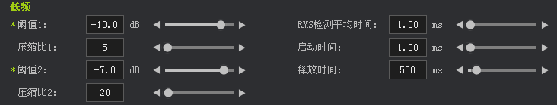
Fig 23 Standard DRC parameter setting 2
PS: standard DRC support setting for some parameters under different values at all levels of the volume, in order to fine tune the volume down the best audio-visual effects, in front of the parameter name , there will be a "star" as its "attenuation", "threshold 1", " threshold 2", etc.

4.1.11 ASET Sound Enhancement Interface
Sound enhancement page: the effect is to enhance sound effects at a small volume.
PS: sound enhancement is gradual, from "threshold value" to "retention threshold" is gradual change, the strongest sound effect is after "maintain threshold".
- Audio enhancement peak ratio: this parameter is used to ensure sound enhancement will not lead to a broken sound distortion, sudden big and small etc. If the sound effects to enhance to enhance a few very close to the PEQ point, because this a few PEQ point influence each other, then the value will be a bit bigger; Generally, you do not need to change the default values。
- High pass weakens: if the high pass filter is used in PEQ, the bass effect will be enhanced if the high pass is weakened. High pass cutoff frequency refers to the minimum frequency of high pass filtering to this frequency point.
- Low frequency enhancement: low frequency enhancement frequency point can be set in PEQ for bass enhancement.
- Enhanced bass enhancement: when the "bass enhancement module" is used, the corresponding value is set to "1", indicating that the gain of the "bass enhancement" module can be enhanced.。
- High frequency enhancement: high frequency enhancement frequency points can be set in PEQ for high-pitched enhancement.
- Enhanced pitch enhancement: when using the "high-pitch enhancement module", the corresponding value is set to "1", indicating that the gain of the "high-pitch enhancement" module can be enhanced.
- The sound enhancement frequency point supports the enhancement of the frequency points used by 3 PEQ. It is necessary to ensure that the frequency point value is equal to some frequency point in PEQ, otherwise it is invalid.
- Threshold value: the threshold value that the sound effect begins to increase.
- Maintain threshold: when the sound effects are enhanced to this threshold, the "increase amplitude" remains unchanged.
- Enhancement amplitude: the maximum sound enhancement of this frequency point.

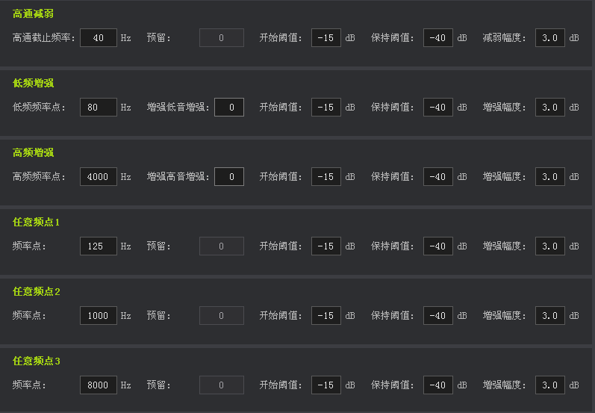
Fig 24 sound effect enhancement interface

4.1.12 ASET Sound Attenuation Interface
Sound attenuation page: the effect is to reduce the sound effect at high volume, to prevent the distortion or breaking of a certain frequency point.Note: the sound attenuation is gradual, from "threshold value" to "retention threshold", which is gradually changed to the minimum after "threshold".
- High pass enhancement: if the high pass filter is used in PEQ, the bass effect will be weakened if the high pass is enhanced. High pass cutoff frequency refers to the frequency of the cutoff frequency of high pass filtering.
- Low frequency: low frequency attenuation frequency, can set some low frequent points in PEQ to reduce the bass.
- Reduced bass enhancement: when the "bass enhancement module" is used, the corresponding value is set to "1", indicating that the gain of the "bass enhancement" module can be reduced.
- High frequency attenuation: high frequency attenuation frequency point, user can set some high frequency point in PEQ to carry on the high pitch attenuation.。
- Attenuation high pitch enhancement: when the "high-pitch attenuation module" is used, the value is set to "1", indicating that the gain of the "high-pitch enhancement" module can be reduced.
- The sound attenuation frequency point supports the attenuation of the frequency points used by 3 PEQ. It is necessary to ensure that the frequency point value is equal to some frequency point in PEQ, otherwise it is invalid.
- Threshold value: the threshold value that the sound effect begins to weaken.
- Maintain threshold: when the sound effects are reduced to this threshold, the "reduced amplitude" remains unchanged.
- Attenuation: the maximum sound attenuation of the frequency point.

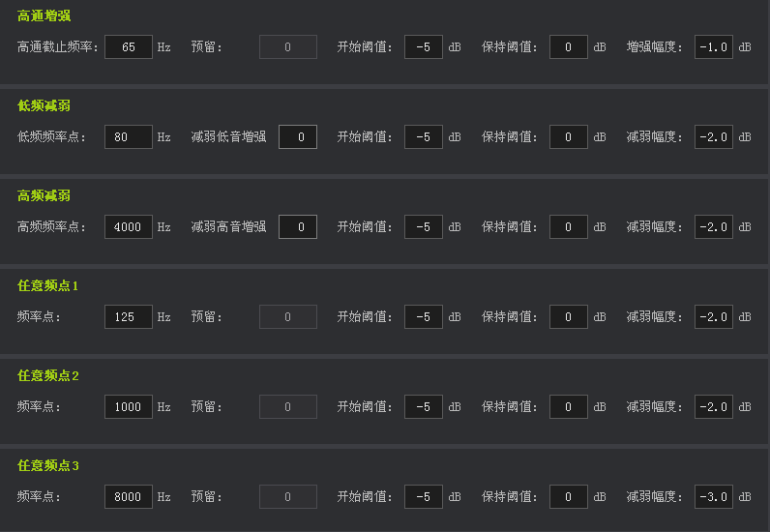
Fig 25 Sound effect attenuation interface

4.1.13 ASET Signal Detection Page
Specially designed for AUX application signal detection, there are five parameters can be adjusted, generally the default setting is ok.
- Signal detection period: represents the time required to detect the signal.
- Signal detection cycles: how many cycles are needed to indicate the signal。
- Small signal pre-fall threshold: indicates that the signal needs to reach the threshold before it is released.
- Small signal pre-descending cycles: how many cycles are required after the signal reaches the threshold to be released completely.
- Signals effective minimum size: the size of the test results will be restricted is greater than or equal to the minimum, this is used to prevent because of the detected signal is too small, the enhanced sound too much, lead to the problem of low signal noise ratio (SNR).The range is 0dB ~ -80db, and the default is -60db.
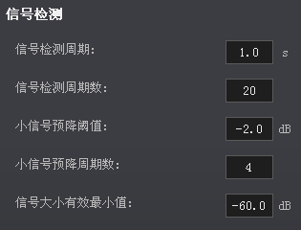
Fig 26 signal detection page

Sound Debugging Method

5.1 Sound Debugging Process
Sound adjustment is a complicated process. A good tuner needs to have the audio debugging and audio test capability of the hardware engineer. At the same time, it also requires the listening ability.in addition, a good tunner should adjust different parameters according to different sound effects process in order to get the best sound effect.

5.1.1 ASET sound flow chart in smart mode
US282X ASET smart mode sound signal process：
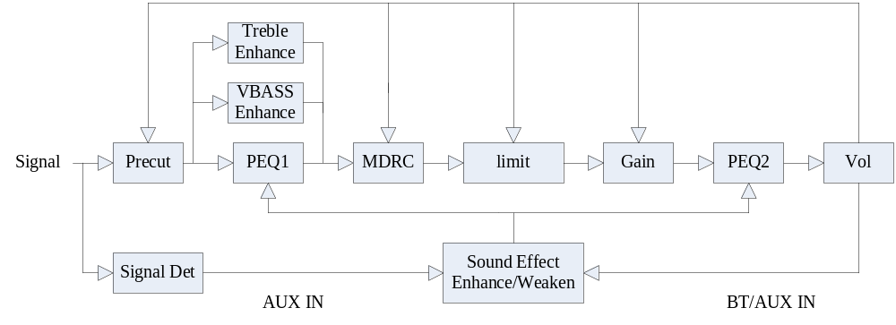

5.1.2 ASET Standard Mode Sound Effect Flow
US282X ASET standard mode sound signal process：

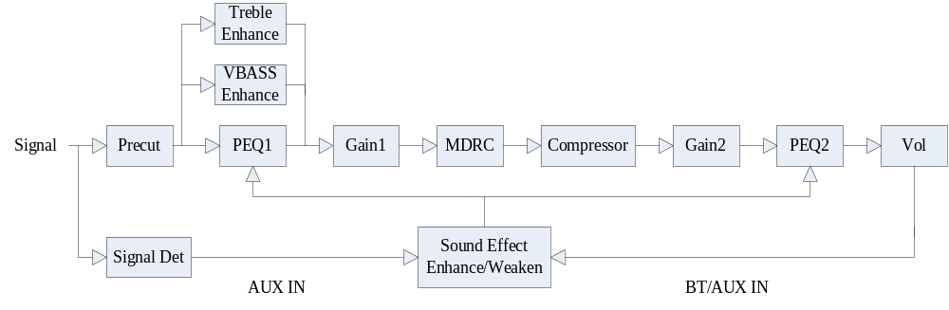

5.1.3 Tuning Process of Sample Speaker
The general tuning process is as follows: firstly, the debugging and testing of the hardware platform of the prototype itself; then close ASET sound effects and test audio indicators; at last, add ASET sound effects, debug ASET parameters and retest the audio indicator parameters.

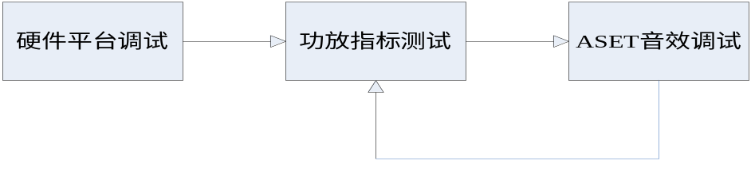
Fig 27 tuning flow chart 1

5.1.4 Tuning Process of Same Cavity Body
If there is a comparison reference prototype, and the sample machine and reference prototype are used in the same cavity; We can refer to the electrical signal indicator and the sound signal indicator of the sample machine first, and then the sample machine can be adjusted by adjusting the parameters to make the electric signal and the reference prototype consistent.。
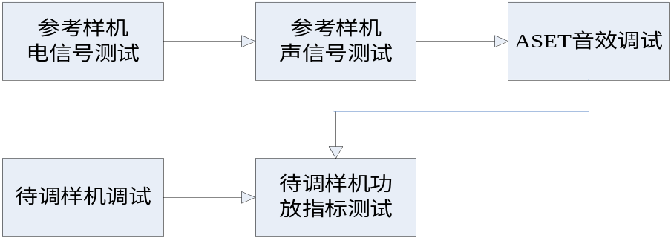
Fig 28 tuning flow chart 2

5.1.5 Tuning Process of Different Cavity Body
If there is a comparison reference prototype, but the sample machine and reference prototype use different cavity; First, test the electrical signal of the reference prototype for reference, and then test the sound signal of the reference prototype; The sound signal is tested by listening or acoustic instrument to ensure that the sound signal is in accordance with the sample machine, and then the sound parameters can be fine-tuned through the audition.

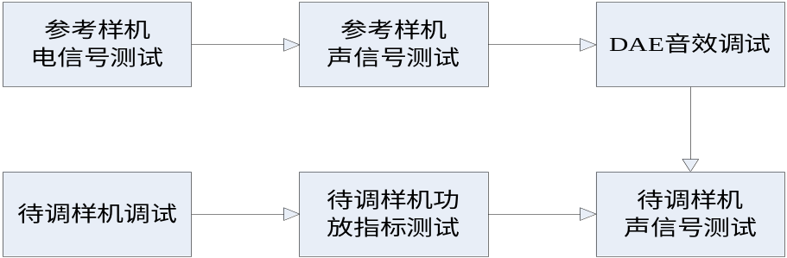
Fig 29 tuning flow chart 3

5.2 Audio Index Test Item
通过客观的指标参数，可以在某种程度上反映音箱的听感状况，音频指标反馈了音箱样机硬件平台的优劣，直接决定了增加ASET音效后的听感好坏。

5.2.1音箱音频指标说明
一般来说，一台音箱的音频指标会很多，但对于调音而言，要能保证基本的指标是在SPEC要求范围以内的。音频指标包括电信号指标和声学信号指标。

5.2.2电信号音频指标测试
- 最大输出功率
最大输出功率决定了音箱样机所能发出的最大响度，通常是根据产品的SPEC来制定的，如产品规格书要求：最大输出功率2×5W@4欧，那每个声道的最大功率输出就是5W。
- 失真度(THD+N)
失真度表示整个音箱系统所能还原信号的能力。通常也是根据产品的SPEC来制定，如产品规格书要求：THD+N≤0.2%@1W@4欧，表示在输出1W且负载为4欧时，THD+N要小于0.2%。一般而言，对于最大的输出功率时，THD+N要小于1%，否则增加ASET音效，特别是重低音时，容易产生破音现象。
- 频响曲线
频响曲线指在音频频段内各频点的幅度测试；一般的频响曲线都是一条平直的曲线；但为了满足不同人群的听感需求时，可以把频响曲线在特定的频率做不同的改变，或者有时为了补偿喇叭，也会把一些频点提升和降低，以使各频段达到平衡。
- THD+N曲线
THD+N曲线指在音频频段内各频点的THD+N值的测试；在测试最大输出功率和频响曲线的同时，都会增加THD+N曲线的测试。好的样机需要在音频范围内频点的THD+N值都不要超过1%，如果有偏离较大的值，则需要制作此频点的单音文件，测试其FFT，进而分析之。
- 灵敏度曲线
随着输入的变大(LINEIN通常是10mV至950mV)，输出功率的变化情况；从灵敏度曲线上可以看出灵敏度，限制功率等参数。

5.2.3声学指标测试
- 声频响曲线
声频响曲线反映了由电信号通过喇叭和腔体的作用后出来声音信号的特性。
- 喇叭腔体阻抗曲线
喇叭和腔体的阻抗曲线是反映喇叭和腔体发声的物理特性，从曲线上可以看出：喇叭的谐振频率F0，此频率是系统低音重放的下限频率，F0越低，表明系统的低音重放效果越好；腔体的谐振频率F1；喇叭的Q值，其表明振动系统的阻尼状态（即振动衰减的快慢）和共振锐度，振动很快停止的叫Q值低，振动不易停止的叫Q值高。Q值过低时，音乐低频部分会衰减过大，听感上表现为低音没有震撼力；Q值过高时，音乐低频部分得到过分加强，共鸣声较长，有点模糊不清。

5.3 调音过程
调音过程分硬件调试部分和ASET音效调试部分；调节步骤如下：

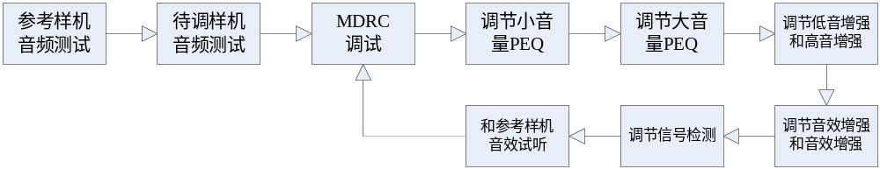 图30 调音流程框图4

5.3.1 参考样机音频指标测试
如果参考样机可以拆机，那最好是拆机测试参考样机的电信号：小音量的EQ和THD+N曲线，中等音量时的EQ和THD+N曲线，大音量时的EQ和THD+N曲线，大音量时的灵敏度曲线 (如果参考样机具有灵敏度功能)。
1．小音量的EQ和THD+N曲线，
2．中音量的EQ和THD+N曲线，
3．大音量的EQ和THD+N曲线，如下图：
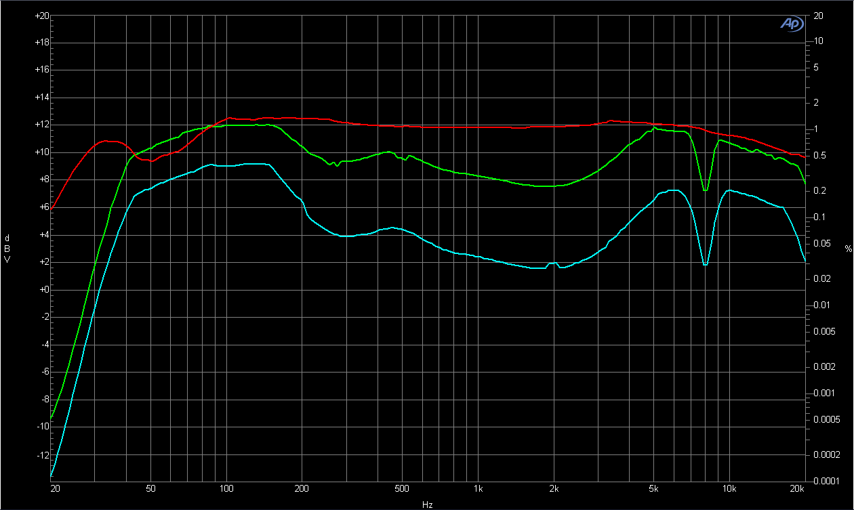
图31 电PEQ曲线测试
4．大音量时，不同频率的灵敏度曲线：
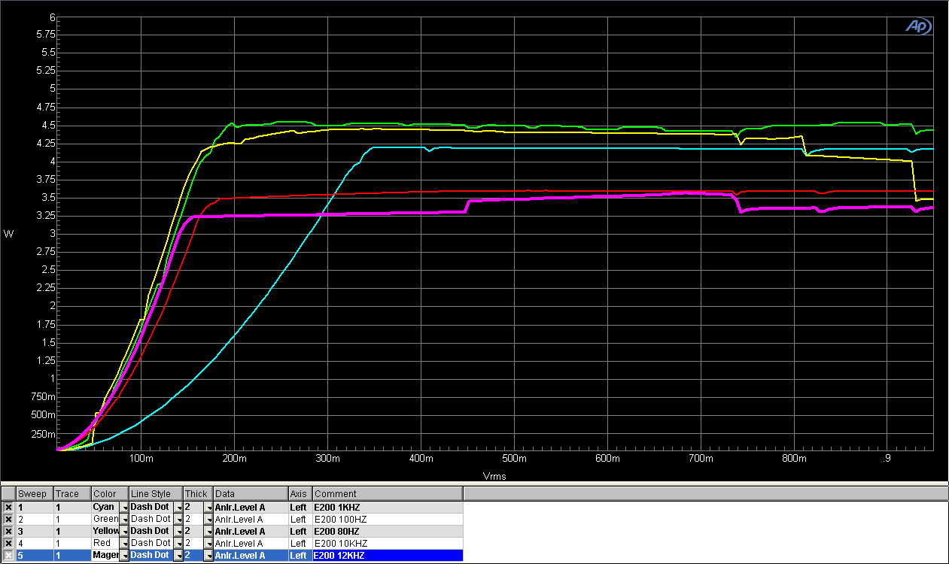
图32 灵敏度曲线测试
如果参考样机不可以拆机，则只能测试参考样机的整机声频响：小音量的声频响曲线，中音量的声频响曲线，大音量的声频响曲线。
1．小音量的声频响曲线，
2．中音量的声频响曲线，
3．大音量的声频响曲线，如下图，各级音量等级下的声频响曲线：
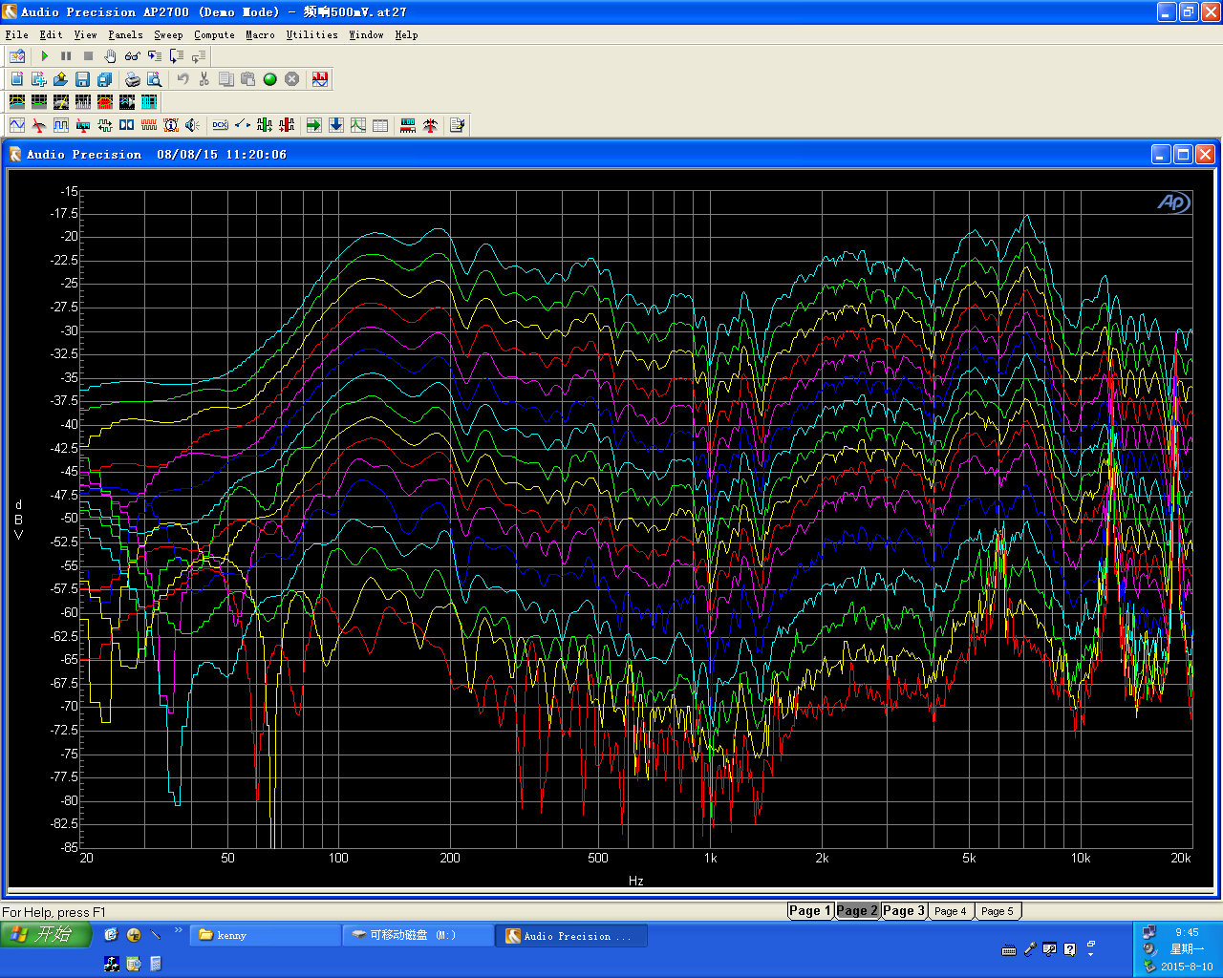
图33 声频响曲线测试

5.3.2 待调样机音频测试
为了保证硬件平台的音频指标，首先需要在ASET关闭时的指标测试，此时需要测试样机的最大输出功率，且要求最大输出功率时的THD+N要小于1% (对音质要求很高的客户THD+N在0.5%以内，对音质要求不高的客户THD+N可以在5%以内)。

- 智能MDRC调节测试

通过ASET工具把MDRC和Limiter打开后，其他模块不要打开，且PEQ页面的“等效预衰减”要设置成0dB；假设PEQ频点增加的最大值为A0，则需要把预衰减Precut设置成-A0dB，测试MDRC的功率输出曲线。
- 首先设置MDRC的分频点，默认会把分频点设置为125HZ和6KHZ，这个值可以根据后面的听音再来调节。
- 调节“与Limiter差值”这个参数，在测试指标参数时，可以采用默认值1.5dB；后面试听时可以根据听再来调节；一般这个参数值越小，声音会更透彻，但DRC压缩得越厉害；参数值越大，声音会更平稳。
- 调节中频段的MDRC参数(此时需要把低频段及高频段的MDRC阈值设置成和中频段的一致)；通过调节“MDRC的阈值”来设置MDRC的灵敏度，如把灵敏度设置成350mV；再通过调节“功率微调”和“信号减弱”来调整限制输出功率，如把限制功率输出设置成5W。
- 设置低频段的MDRC参数，通过调节“MDRC的阈值”来设置低频段的限制输出功率。
- 设置高频段的MDRC参数，通过调节“MDRC的阈值”来设置高频段的限制输出功率。

- 标准DRC调节测试

标准DRC的流程具有调节方便，易懂，适合经验丰富的调音师使用。由于标准DRC支持各音量等级下有不同的音效参数，所以调节完最大音量的参数完后，还需要再调各级音量的参数；各级音量下，可以调节的参数名称前有“星号”标注，参数有：
- 预衰减；
- 压缩器的阈值1，阈值2，压缩器的压缩比1，压缩比2；
- 信号微调，增益补偿；
- 补偿滤波器阈值；
- DRC各频段的阈值1，阈值2，压缩比1，压缩比2。

注：调节各级音量的参数时，也需要分AUX模式和非AUX模式，且需要把工具右下角的音量调节按钮设置到相应的音量等级。

- 调节小音量时的PEQ曲线

把参考样机测试到的小音量PEQ曲线导入ASET工具作为参考曲线，然后通过调节均
衡器页面的PEQ点，设置不同的频点，增益，Q值，滤波器类型等参数，来达到和参考样机一样的曲线。然后使用AP测试，是否在小音量时达到了和参考样机一样的曲线。

- 调节大音量时的PEQ曲线

大音量下，当MDRC起作用时，理论上PEQ曲线会是一条平直的曲线，如果想要衰掉
某个频点，则可以把PEQ点的状态设置成POSTEQ状态，再次用AP测试时会发现，曲线在大音量时把该点的PEQ衰减了一部分，从而达到满足听感的要求。

- 调节低音增强和高音增强

在小音量或大音量下，如果通过PEQ调节到的低音效果和高音效果不满意，则可以通过调节低音增强和高音增强算法来达到更满意的低音和高音效果；当然调节的结果是不能有破音。

- 调节音效增强和音效减弱

在调试好输出功率和EQ曲线后，我们可以对小功率时和大功率时的听感进行修正；当输出功率较小时，可以微调EQ，比如可以把低频EQ增益调大，让小音量的低频更强些；
当输出功率很大时，会容易产生破音和失真等问题，此时可以把某些EQ点增益降低些，让大音量下不至于破音。

- 调节信号检测模块

如果想要在AUXIN下有更好的效果，则可以打开此模块，使用默认的参数即可。

- 在线试听

在调节好以上模块后，可以在线试听，如果听感不满足，再返回调节以上参数。如果
OK，则保存好ASET参数；如果是标准DRC模式，还需要再调节各音量等级下的参数。

- 打包固件试听

在线试听OK后，将ASET参数导成 *.txt 文件，打包到固件，然后升级到小机，就可以试听确认了。

5.4 音乐试听技巧
以上各项音效调试完成后，或有时需要边调试边试听；音质试听主观性比较强，音质的好坏大都因人而异；不同的人有不同的喜好程度；不同的音乐反映的听感也不一样。

5.4.1试听环境
为了试听感受的正确性，最好在试听房或安静的环境下试听，以减少外界的的噪声干扰。因为不同的人可能感受不一样，特别是对于一些差异在感情色彩方面的样机，特别要如此。但对于大多数专业的调音师，得出的结论一致性会比较好。

5.4.2好音质的基本判别
一般而言，好的音箱应具有如下的听感：低频下潜要好，有一定的低频动态感，低频不干涩，不破音；中频人声要明亮透彻，无鼻音及齿音，人声声场宽阔；高频不刺耳，耐听。

5.4.3试听歌曲
试听歌曲一般要求320kbps比特率以上的MP3或Wav；这样更能听出细节上的差异。不同的频段及不同的感情色彩需要试听不同的歌曲。高音一般使用高音女声或小提琴类的歌曲；中音一般是男中音歌手的歌曲，低音则是打鼓声或低音歌唱家的歌曲。目前常用的试听曲子如下表所示：
试听项 | 试听歌曲
低频 | Burn | 渡口 | 鼓诗 | Abracadabra | 加州旅馆
人声中频 | 船歌 | 匆匆那年 | 恰似你的温柔 | 北京北京 | Way down deep
人声高频 | Angle | Hello | Turning Tables | 青藏高原 | 天堂
钢琴曲 | 街道的寂寞 | 夜的钢琴曲 | 风继续吹 | 有谁共鸣 | 只怕不再遇上
容易破音的歌曲 | 渡口 | Angle | Hello | Strobe | 恰似你的温柔

5.4.4简单频响测试APP
当在工厂现场调音，而没有AP和声学测试仪器时，可以在手机上安装一个简单的信号发生器APP，Iphone手机可以安装“Signal Gen”软件，此软件可以产生20Hz-20KHz的音频正弦波信号。此时待调样机和参考样机可以播放相同频率的单音，试听待调样机的单频响度是否和参考样机的一致，如果不一致，而需要在PEQ上把该点的幅度和Q值做修改。一般会听30HZ，40HZ，50HZ，60HZ，80HZ，100HZ，150HZ，200HZ，300HZ，400HZ，500HZ，800HZ，1KHZ，2KHZ，3KHZ，4KHZ，5KHZ，6KHZ，7KHZ，8KHZ，9KHZ，10KHZ，12KHZ，14KHZ，16KHZ，20KHZ等频点。

5.4.5听感主观描述
目前音质的试听大都以主观语言感情描述为主。为了进行音质的主观评测，一些专业的音频专家确定了一些最能描述声音主观属性和参量，以及参量的形容词作为主观评价和常用术语，如丰满度的术语是丰满，干瘪等；声音的感情色彩用“柔和”，“暖”，“硬”等描述；此外还有一些和频率有关的听感描述。

- 和频率有关的主观描述

频率段 | 听感描述 | 代表的乐器
20－60HZ | 这段频率影响音色的空间感，乐音的基音大多在这段频率以上。这段频率是房间或厅堂的谐振频率。这段频率很难表现，在一些HiFi音响中，不惜切掉这段频率来保证音色的一致性和可听性。 | 爆炸声、Disco
60－100HZ | 这段频率影响声音的混厚感，是低音的基音区。如果这段频率很丰满，音色会显得厚实、混厚感强；如果这段频率不足，音色会变得无力；而如果这段频率过强，音色会出现低频共振声，有轰鸣声的感觉。 | 大鼓、定音鼓，还有钢琴、大提琴、大号等少数存在极低频率的乐器。
100－300HZ | 这段频率影响声音的力度，尤其是男声声音的力度。在80－160Hz频段的声音主要表现音乐的厚实感，音响在这部分重放效果好的话，会感到音乐厚实、有底气；如果表现不好，音乐会有沉闷感，甚至是有气无力。是许多低音炮音箱的重放上限。 | 男声
300－500HZ | 这个频段的声音主要是表现人声的（唱歌、朗诵），这个频段上可以表现人声的厚度和力度，好则人声明亮、清晰，否则单薄、混浊。 | 人声、部分打击乐器
800HZ | 这个频率幅度影响音色的力度。如果这个频率丰满，音色会显得强劲有力；如果这个频率不足，音色将会显得松弛，也就是800Hz以下的成分特性表现突出了，低频成分就明显；而如果这个频率过多了，则会产生喉音感。如果喉音过多了，则会失掉语音的个性，适当的喉音则可以增加性感。
1KHZ | 这个频率是音响器材测试的标准参考频率，通常在音响器材中给出的参数是在1kHz下测试。这是人耳最为敏感的频率。
1.2KHZ | 这个频率可以适当多一点(不宜超过3dB)可以提高声音的明亮度；过多则会使声音发硬。
2－4KHZ | 这个频率成分如果过少，听觉能力会变差，语音显得模糊不清；如果这个频率成分过强了，则会产生咳声的感觉。同时这个频段对音乐的层次感影响较大，有适当的提升可以提高声音的明亮度和清晰度，但是在4kHz时不能有过多的突出，否则女声的齿音会过重。 | 部分女声、以及大部分吹奏类乐器。
4－8KHZ | 这段频率最影响语音的清晰度、明亮度、如果这频率成分缺少，音色则变得平平淡淡；如果这段频率成分过多，音色则变得尖锐，人声可能出现齿音。 | 部分女声、以及大部分吹奏类乐器。
8－12KHZ | 这个频段是音乐的高音区，对音响的高频表现感觉最为敏感。适当突出（5dB以下）对音响的的层次和色彩有较大帮助，也会让人感到高音丰富。但是，太多的话会让人感到声音发尖、发毛。如果这段缺乏的话，声音将缺乏感染力和活力。 | 长笛、双簧管、小号、短笛等高音管乐器。
12－16KHZ | 这段频率能够影响整体的色彩感，这段频率过于黯淡会导致乐器失去个性，过多则会产生毛刺感。 | 镲、铃、铃鼓、沙锤、铜刷、三角铁等打击乐器的高频泛音。
16－20KHZ | 这段频率可能很多人都听不到，但这段频率可以影响高频的亮度，以及整体的空间感，这段频率过少会让人觉得有点闷，太多则会产生飘忽感，容易产生听觉疲劳。 | 电子合声、古筝钢琴等乐器的泛音。

- 和主观心理感情色彩相关的描述
主观术语 | 主观描述 | 具体解释
清晰度 | 清晰，模糊，浑浊 | 节目可懂度高，乐队乐器层次分明，有清澈见底之感。
平衡度 | 平衡，不平衡 | 节目各声部比例协调，立体声左，右声道的一致性好，声像正常。
丰满度 | 丰满，单薄，干瘪 | 中低音充分，高音适度，响度合宜，有温暖，舒适感，有弹性。
力度 | 坚实有力，力度不足 | 声音坚实有力，能出得来，能反映原声源的动态。
圆润度 | 圆润，毛糙 | 优美动听，有光泽但不尖糙，主要用以评价人声和某些乐器。
明亮度 | 明度，灰暗 | 高，中音充分，听感明朗，活跃。
柔和度 | 柔和，尖硬 | 声音松驰不发紧，高音不刺耳，听感悦耳舒服。
融合度 | 融合，松散 | 整个音响交融在一起，整体感好。
真实感 | 真实，失真 | 声音逼真， 失真：声音破，炸，染色等。
临场感 | 临场感 | 重放出的声音使人有“身临其境”的感觉。
立体感 | 立体，单一 | 声音有空间感，不仅声像方位基体准确，声像群分布正确，而且有宽度和纵深感。

5.4.6 听音与各频段的调节关系
一般来说，听音师会根据自己听到的音乐品质，进行各频段的调节，当各频段的成分过高或过低时，都会对整机有明显的感觉，一般的调节规则如下：

频段 | 范例 | 调节过低 | 适中 | 调节过高 | 简明
20Hz-60Hz | 31Hz | 空虚 | 空间感良好 | 低频共振声显现“嗡”的声音 | 空间感
60Hz-100Hz | 62Hz | 无力 | 浑厚感强 | 低频共振声显现“轰”的声音 | 浑厚
100Hz-150Hz | 125Hz | 单薄 | 丰满度增强，混浊 | 混浊，显现“哼”声 | 饱满
150Hz-300Hz | 250Hz | 软绵绵 | 声音力度强 | 生硬 | 力度
300Hz-500Hz | 500Hz | 空洞 | 语音有力度感 | 有电话声音色
500Hz-1KHz | 500Hz | 有收缩感 | 声音的轮廓明朗 | 声音向前凸出 | 喉音
800Hz | 500Hz | 松弛感 | 强劲感 | 喉音重，鼻音 | 鼻音
1-2KHz | 1KHz | 松散，使音色脱节 | 通透感强 | 跃感 | 通透
2-3KHz | 2KHz | 朦胧 | 明亮度增强 | 呆板 | 明亮
4KHz | 4KHz | 模糊 | 穿透力强 | 咳音量
4-5KHz | 4KHz | 音源边远 | 响度感强 | 声音变近，人声靠前 | 靠前
5-6KHz | 4KHz | 含糊 | 清晰度强 | 尖利
6-8KHz | 4KHz | 暗淡 | 透明 | 齿音重
8-10KHz | 8KHz | 平淡 | S音明显，通透感 | 尖锐 | S音
10-12KHz | 16KHz | 乏味，失去光泽 | 金属声强烈 | 尖噪
12-16KHz | 16KHz | 失掉色彩 | 金光四溅 | 刺耳 | 金属
16-20KHz | 16KHz | 韵味失落，色彩失落，缺乏音色表现力 | 靠人体颚骨传导感受声音的韵味，色彩富于音色表现力 | 宇宙声感和不稳定感

Package Firmware Process for Sound Parameters
1. After debugging the sound parameters, it is necessary to export the sound parameters to the TXT format file through the corresponding button .

Fig 34 button for extract the para configuration
2．Open the Media Firmware Modify Tool and select the path to Modify, as shown in the figure below.
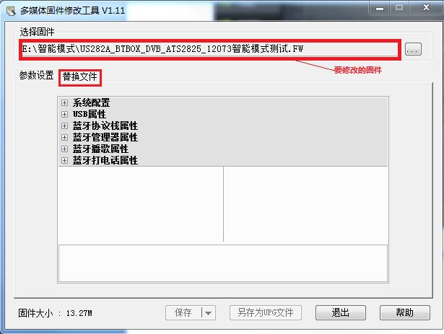
Fig 35 Firmware Modify Tool

3．Click the replacement file to get the image below:

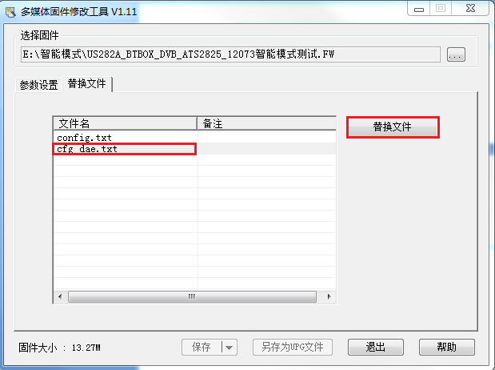
Fig 36 replacement file
4．Select cfg_ASET. txt, and then select the replacement file actions_ASET. txt , then will pop up the following dialog box.
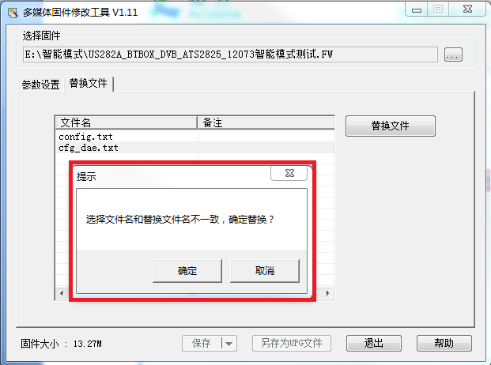
Fig 37 replace dialogue

- Click ok and save to generate a new xxxxxxxx.fw firmware, which contains the new sound parameters.

- 限幅器limiter; limitator; limitr
- 信号溢出signal overflow
- 超标overproof
- 阈值threshold; threshold value
- 输出功率output power
- 启动时间startup time
- 释放时间release time
- 开启open; unlock; turn on; unseal
- 关闭时间turn-off time
- 长短length; accident; mishap; right and wrong

声 明
Disclaimer
Information given in this document is provided just as a reference or example for the purpose of using Actions’ products, and cannot be treated as a part of any quotation or contract for sale.
Actions products may contain design defects or errors known as anomalies or errata which may cause the products’ functions to deviate from published specifications. Designers must not rely on the instructions of Actions’ products marked “reserved” or “undefined”. Actions reserves these for future definition and shall have no responsibility whatsoever for conflicts or incompatibilities arising from future changes to them.

ACTIONS DISCLAIMS AND EXCLUDES ANY AND ALL WARRANTIES, INCLUDING WITHOUT LIMITATION ANY AND ALL EXPRESS OR IMPLIED WARRANTIES OF MERCHANTABILITY, ACCURACY, SECURITY, FITNESS FOR A PARTICULAR PURPOSE, TITLE, AND AGAINST INFRINGEMENT OF INTELLECTUAL PROPERTY AND THE LIKE TO THE INFORMATON OF THIS DOCUMENT AND ACTIONS PRODUCTS.
IN NO EVENT SHALL ACTIONS BE LIABLE FOR ANY DIRECT, INCIDENTAL, INDIRECT, SPECIAL, PUNITIVE, OR CONSEQUENTIAL DAMAGES WHATSOEVER, INCLUDING, WITHOUT LIMITATION FOR LOST OF DATA, PROFITS, SAVINGS OR REVENUES OF ANY KIND ARISING FROM USING THE INFORMATON OF THIS DOCUMENT AND ACTIONS PRODUCTS. REGARDLESS OF THE FORM OF ACTION, WHETHER BASED ON CONTRACT; TORT; NEGLIGENCE OF ACTIONS OR OTHERS; STRICT LIABILITY; OR OTHERWISE; WHETHER OR NOT ANY REMEDY OF BUYER IS HELD TO HAVE FAILED OF ITS ESSENTIAL PURPOSE, AND WHETHER ACTIONS HAS BEEN ADVISED OF THE POSSIBILITY OF SUCH DAMAGES OR NOT.

Actions’ products are not designed, intended, authorized or warranted for use in any life support or other application where product failure could cause or contribute to personal injury or severe property damage. Any and all such uses without prior written approval of an Officer of Actions and further testing and/or modification will be fully at the risk of the customer.

Ways of obtaining information
Copies of this document and/or other Actions product literature, as well as the Terms and Conditions of Sale Agreement, may be obtained by visiting Actions’ website at: http://www.actions-semi.com or from an authorized Actions representative.

Trademarks
The word “Actions” and the logo are the trademarks of Actions Semiconductor Co., Ltd, and Actions (Zhuhai) Technology Co., Limited is authorized to use them. Word “炬芯” is the trademark of Actions (Zhuhai) Technology Co., Limited. Names and brands of other companies and their products that may from time to time descriptively appear in this document are the trademarks of their respective holders, no affiliation, authorization, or endorsement by such persons are claimed or implied except as may be expressly stated therein.

Rights Reserved
The provision of this document shall not be deemed to grant buyers any right in and to patent, copyright, trademark, trade secret, know how, and any other intellectual property of Actions or others.

Miscellaneous
Information contained or described herein relates only to the Actions products and as of the release date of this publication, abrogates and supersedes all previously published data and specifications relating to such products provided by Actions or by any other person purporting to distribute such information.
Actions reserves the rights to make changes to information described herein at any time without notice. Please contact your Actions sales representatives to obtain the latest information before placing your product order.

Additional Support
Additional products and company information can be obtained by visiting the Actions website at: http://www.actions-semi.com

炬芯（珠海）科技有限公司

地址: 珠海市唐家湾镇高新区科技四路1号1#厂房一层C区
电话：+86-756-3392353
传真：+86-756-3392251
邮政编码：519085
网址：http://www.actions-semi.com
电子邮件 （业务）: mp-sales@actions-semi.com
（技术支持）: mp-cs@actions-semi.com

